Automated Diagnosis of Brain Tumor based on Deep Learning Feature Fusion using MRI Images

Kondepudi Venkata Durga  
 *Department of CSE*  
*C.V.Raman Global University* Bhubaneshwar, India  
 venkatdurgakondepudi@gmail.com

Amballa Vijay Sai Charan Naidu  
*Department of CSE*  
 *C.V. Raman Global University* Bhubaneshwar, India  
 charan.amballa@gmail.comK.Rahul  
*Department of CSE*  
*C.V.Raman Global University*Bhubaneshwar, India  
korkanarahul@gmail.com

Majji Jayanth Kumar  
 *Department of CSE*  
*C.V.Raman Global University* Bhubaneshwar, India, jayanthmajji45@gmail.com

Prof. Debendra Mudil  
*Department of CSE*  
 *C.V.Raman Global University* Bhubaneshwar, India  
 muduli.debendra@gmail.com

*Abstract*— Brain tumor detection is an important task in medical image analysis, as early detection is crucial for the patient's treatment and survival. In recent years, deep learning has shown remarkable success in various medical imaging tasks, including brain tumor detection. In this paper, we compare the performance of 8 pre-trained Convolutional Neural Network (CNN) models using ImageNet dataset weights in order to identify the best suitable model. We use the publicly available Brain MRI scans for Brain Tumor Detection (BRATS) modified dataset for training and testing our model. The models were evaluated using publicly available MRI images, with InceptionV3+VGG19 achieving the greatest accuracy of 96%. We used the Adam optimizer and also evaluated the performance of this combined model using various evaluation metrics, including accuracy, precision, recall, and F1 score. This study demonstrates the potential of deep learning in medical image analysis and can help clinicians in early detection of brain tumors.

*Keywords—Brain tumor, Magnetic resonance imaging, (MRI), InceptionV3, VGG19, Deep learning, medical imaging.*

# INTRODUCTION

The brain, which is made up of billions of cells, is one of the most important parts of the human body. A brain tumour is an abnormal development of brain cells that can produce neurological symptoms such as seizures and headaches. Early and accurate diagnosis of brain tumours is critical in this type of cancer, which is deadly [1]. Brain tumors are a serious health issue and their early detection is crucial for effective treatment. Traditional methods of detecting brain tumors involve invasive procedures, such as biopsy and surgical removal, which can be risky and time-consuming. In particular, transfer learning using the InceptionV3 + VGG19 deep learning model has shown promising results in accurately detecting brain tumors from MRI scans.

Brain magnetic resonance imaging (MRI) is one of the most effective ways of imaging for detecting brain tumours and demonstrating tumour development in both the detection and therapy phases. Because of their great resolution, MRI pictures have a significant impact on the field of automatic medical image analysis [2]. This is owing to their capacity to provide a wealth of information on brain anatomy and disorders inside brain tissues.

Transfer learning involves using pre-trained deep learning models, such as InceptionV3, VGG16, VGG19, Xception, DenseNet and training them on a new dataset, in this case, brain MRI scans. This approach has shown great success in many computer vision applications, including medical imaging. By using transfer learning, the model can learn to detect patterns and features specific to brain tumors, leading to accurate and efficient detection. InceptionV3+VGG19 is a state-of-the-art combined DL model that was originally trained on a large image dataset, ImageNet. This model has shown superior performance in image classification tasks, and by adapting it to detect brain tumors, it has the potential to significantly improve current methods of brain tumor detection. The use of transfer learning with InceptionV3+VGG19 can greatly reduce the amount of time and resources needed to develop accurate brain tumor detection systems, making it a valuable tool for medical professionals [1,2].

The previous works include Computer-Aided Diagnosis (CAD) systems involving multiple computing methods such as Long Short-Term Memory (LSTM), Principal Component Analysis (PCA) and Support Vector Machines (SVM). Afshar et al. [3] introduced a modified CNN model with customized layers which gives an accuracy rate of 86.56%. Maheshwari et al.[4] used 3 transfer learning In their work, they used CNN models to classify brain tumour data. They applied the transfer learning idea and achieved 95% accuracy in the Resnet50 model. Shahzadi et al. [5] employed the VggNet-Lstm hybrid CNN model with the highest accuracy rate of 84% and they compared it with a different hybrid model like Alexnet-Lstm, ResNet-Lstm. Mohsen et al.[6] have proposed a CAD model based on DWT and DL methods that obtained an accuracy of 93.94%.

In their proposed ML technique, Charfi et al.[7] used the histogram equalisation method for image pre-processing. He also included PCA. Finally, neural networks were used in the categorization process. SVM was used to categorise brain tumour data by Vani et al. [8]. They achieved an accuracy of 82% in their research. Citak et al. [9] stated that in their brain tumour study, they used three distinct machine-learning techniques. These algorithms are SVM, multi-layer perceptrons, and logistic regression. As a result, their accuracy was 93%. On the ImageNet[16] dataset, research was conducted by Le et al. [10]. They developed a high-performance object detector using CNN theory that outperformed earlier studies on the ImageNet dataset by a factor of about 70%.

The rest part of the paper has been designed like this: In Section II of the article, the proposed methodology part has been discussed. Section III contains experimental analysis and results. Finally, Section IV contains the conclusion of the proposed work.

# The PROPOSED METHODOLOGY

The objective of this study is to automatically detect brain tumours in brain MRI scans. Fig. 1 shows the flow diagram of the proposed model. InceptionV3+VGG19 with Adam optimisation serve as the key component of our suggested method for detecting brain tumours from brain MRI images. The suggested process involves several stages. The input image is initially collected from the brain MRI database. Next, data augmentation is performed on training data. After that, the images are loaded and pre-processed using the (InceptionV3+VGG19) combined model and produce the output. InceptionV3 and VGG19 are the most advanced neural networks used as image classifiers in the pre-trained CNN model, which was trained on the ImageNet dataset.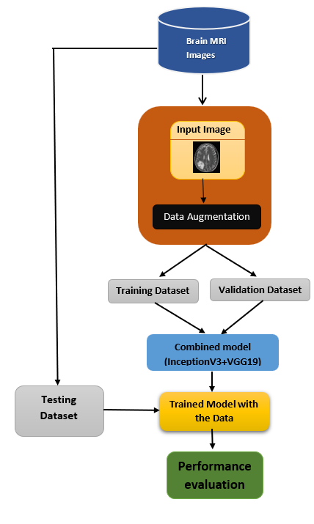

Fig. 1. The flow diagram of this work.

MRI scans of the brain were included in the database used for this study. In total, there are 2026 different-sized raw images. The images are taken from brain MRI imaging datasets on Kaggle[11]. In JPG format, they are. Based on whether tumours are present, the dataset is divided into two classes: YES and NO. They are 1000 images of normal brains, and the total number of images with brain tumours is 1026. Samples of the dataset's images are shown in Fig 2.

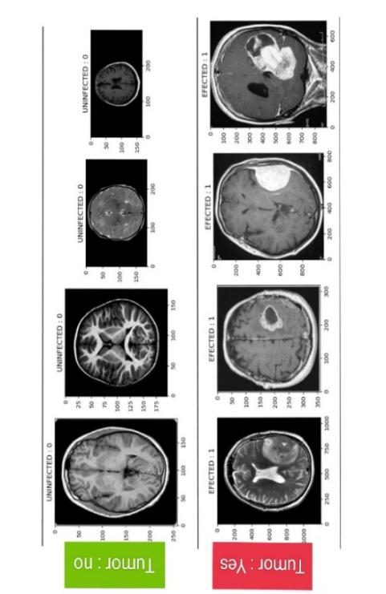Fig. 2. Brain MRI images dataset sample

## Data Augmentation and Pre-processing

A detailed description of the steps used in the pre-processing phase is mentioned in this part:

**Data Augmentation**is a technique used in DL to increase the number of images in training data by creating more training examples by using different transformations of the original data. where variations in rotation, horizontal flip, image dropping, and other factors can significantly affect the accuracy of the model.

**Splitting**data into training and validation sets is a crucial step in developing DL models. The dataset is split into 2 parts, with 80% of the data is used in training or 20% of the data is used for validation. All images in the dataset were Gray-scale and were rescaled using a multiplication factor of 1/255 with the pixel values for achieving the desired output.

## Brain tumour detection using pre-trained CNN models

A form of neural network called a convolutional neural network (CNN) is capable of accurately classifying images by analyzing their key features. They perform more efficiently than other DL models in image classification because they are especially well-suited for this task. The convolution layer, the pooling layer, and the fully connected layer are the three primary layers of a conventional CNN architecture.

In medical image processing applications, CNN models have proven to be quite effective. Due to the less available data on MRI samples, it can be challenging to train these models from scratch to predict brain tumor instances. This challenge can be overcome by applying transfer learning (TL). TL involves using the knowledge of Deep Learning (DL) instead of using a huge dataset to complete a job using a smaller dataset, this eliminates the need for a huge dataset and makes model training easier.

## Proposed model

In this paper, eight pre-trained models consisting of 4 individual models and 4 combined model such as VGG-16, VGG-19, DenseNet, InceptionV3, InceptionV3+VGG16, InceptionV3+VGG19,VGG16+Xeception,InceptionV3+Xecption which has been trained to predict 1000 classes using 1.28 million images from ImageNet. These models use the entire image as an input and then generate probabilistic outputs of the labels of each object in the image. These networks were chosen for this study to discriminate between brain tumour disease and normal cases because they performed exceptionally well in a variety of computer vision and medical image processing difficulties.

**Table 1**

Details of pre-trained CNN models.

**Models Layers Parameters Input_Layer Output_layer**

**(In million) Size Size**

VGG-16 3 14.7 (224,224,3) (2,1)

VGG-19 3 20 (224,224,3) (2,1)

DenseNet 3 7 (224,224,3) (2,1)

Inception V3 3 21.9 (299,299,3) (2,1)

Inception V3+VGG16 8 39.1 (299,299,3) (2,1)

InceptionV3+Xeception 8 46.8 (299,299,3) (2,1)

Xeception+VGG16 8 38.19 (299,299,3) (2,1)

**Inception V3+VGG19 8 44.4 (299,299,3) (2,1)**

*Table 1*: TL CNN models description

Table.1 illustrates different models used in this study for comparison and the major components of each network. After comparing the pre-defined CNN models mentioned above the best optimal CNN model among them is InceptionV3 + VGG19. Different testing data is used for comparing the trained model which is trained using a modified BRATS dataset [11].

The InceptionV3 + VGG19 is a combined TL model of InceptionV3 and VGG19 by freezing the layers in both TL models. Now passing the inputs through both the models up to the global average pooling layer for obtaining the feature map from both the models then concatenating the output feature maps from both the TL models along the depth axis, resulting in a combined feature map. Then reshaping the concatenated feature map to have the required dimensions and passed it to the global average pooling layer which computes the average value for each channel across the spatial dimensions, resulting in a fixed-size feature vector. After that a fully connected layer with 1024 units and ReLU activation function on top of the pooled feature vector. This layer performs a non-linear transformation to the input data. Finally, the Sigmoid classifier is used for binary classification methods which has two classes 1 and 0.

Below mentioned are regularization methods used in this paper.

**Early stopping is an optimization approach that reduces overfitting while maintaining model accuracy. The main goal of early stopping is to terminate training before a model becomes overfit.**

**Reducing LR** on plateau is used for optimization learning rate. When the accuracy of a matrices stops improving, it reduces the learning rate, allowing the model to converge to an optimal minimum.

**Adam** is an optimization algorithm used in DL this helps the model converts faster and not to get stuck in local minima.it helps model to maintain adaptive learning rate.

We have used **Sigmoid** activation function in output layer of our model in order to predict the probability of input image belongs to yes or no class.

 (1)

Fig 3, the visual representation of proposed model architecture which is shown below

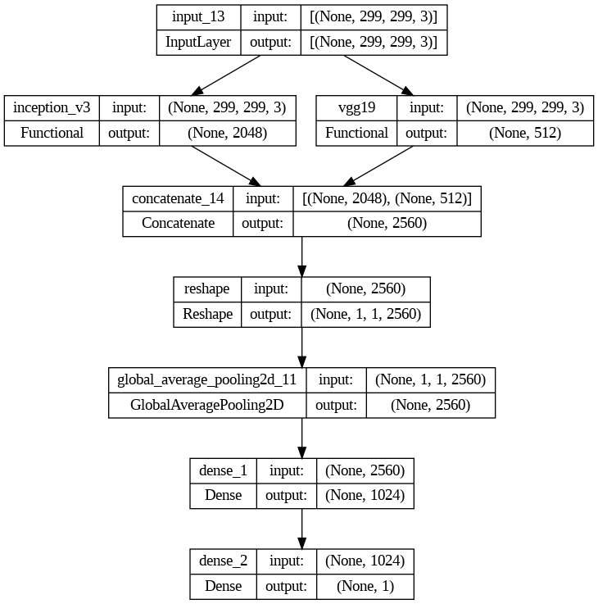

Fig3.Combined TL model (InceptionV3+VGG19) architecture

# Experimental Analysis and result

## Experimental process and evaluation matrix.

The DL models were analyzed using brain MRI scans from BRATS [11]. The model has been trained using enhanced samples with 2026 MRI images obtained after augmentation on training images. These images were then split into training and validating sets with 80% and 20% splitting ratios, generating 1621 images for training and 405 images for validation. The validation set was used to prevent overfitting and build a perfect model.

The input images from MRI were initially scaled to 299 x 299 using VGG-16, VGG-19, DenseNet, Inception-V3,InceptionV3+VGG16,VGG16+Xeception,InceptionV3+Xception, and Inception-V3+VGG19. The batch-size for TL is set to 64. Each one of the models was trained for a total of 25 epochs. An Early stopping method is used. Adam optimizer was used for the training, and empirical decision-making was used to determine the learning rate.

Various performance metrics, are the Precision (Pre) , Accuracy (Acc), F1-score were used to measure each model's performance. These metrics were calculated using several confusion matrix parameters such as True-Positive (TP), False-Positive (FP), True-Negative (TN), and False-Negative (FN). The following are the evaluation metrics:

 (2)

 (3)

 (4)

In this study, Brain tumour were considered positive and normal cases were considered as negative cases respectively. Hence, shows the accurately predicted normal and brain tumour cases respectively.

## Results

The training performance of various networks at different epochs in terms of train_loss, valid_loss, and valid_accuracy is shown in Table.2. Fig.4 displays the train and valid loss for the proposed network over different epochs.

**Table 2**

Training details of all the proposed TL models.

**Model Epochs Train_loss Valid_loss Valid_accuracy (%)**

VGG16 1 0.5303 0.2035 0.9160

... … … …

24 0.0096 0.0317 0.9926

25 0.0096 0.0317 0.9951

VGG19 1 0.4426 0.2317 0.9062

... … … …

24 0.0072 0.0317 0.9951

25 0.0072 0.0317 0.9951

Inceptionv3 1 0.1235 0.0680 0.9926

+Xeception … … … …

24 0.0062 0.0260 0.9975

25 0.0061 0.0255 0.9975

InceptionV3 1 0.3826 0.1783 0.9827

+VGG16 ... … … …

17 0.0144 0.0369 0.9926

18 0.0138 0.0324 0.9901

Xeception 1 0.5720 0.1693 0.9580

+VGG16 ... … … …

14 0.0058 0.0802 0.9630

15 0.0042 0.0368 0.9951

DenseNet 1 0.8528 0.0203 0.9975

... … … …

14 0.0012 0.0039 1.0000

15 0.0012 0.0039 1.0000

InceptionV3 1 0.3748 0.2188 0.9506

... … … …

24 0.0072 0.0314 0.9926

25 0.0071 0.0314 0.9926

**InceptionV3 1 0.4276 0.2628 0.9556**

**+VGG19 ... … … …**

**24 0.0168 0.0453 0.9926**

**25 0.0158 0.0502 0.9926**

*Table 2:* Training Performance

Here in this study, we used an early stopping technique to prevent model from overfitting during training.

The classification results from all networks are analyzed and are shown in Table.3. We can say that the InceptionV3+VGG19 model achieved the best performance with a Pre of 92%, recall of 100% F1-score of 96%, Acc of 96%.

**Table 3**

Classification results comparison of all ten CNN models.

Model Accuracy (%)

1. VGG16 93%
2. VGG19 90%
3. DenseNet 91%
4. InceptionV3 95%
5. InceptionV3+Xecpetion 92%
6. InceptionV3+VGG16 93%
7. VGG16+Xecpetion 77%
8. **InceptionV3+VGG19 96%**

*Table 3*: Testing Accuracy

The graph of training accuracy and validation accuracy for each epoch and the loss convergence graph of training and validation which shows the loss across different iterations for the InceptionV3+VGG19 model are in Fig 4 (a), Fig 4(b) respectively.

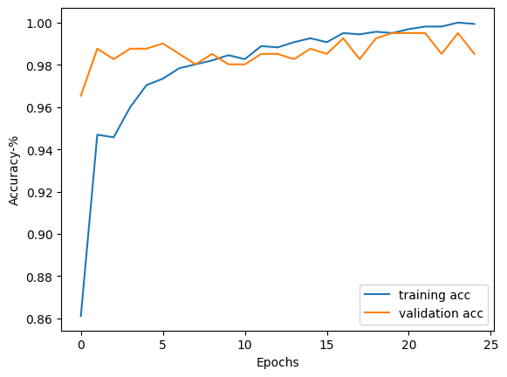

(a)

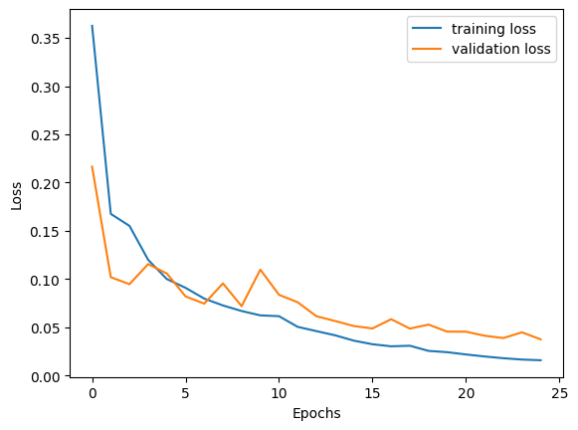

(b)

Fig 4.: (a)Training accuracy plot obtained for InceptionV3, (b) Loss convergence plot obtained for InceptionV3

We presented the confusion matrix of the best performed model which is InceptionV3+ VGG19 with the test data in Fig. 5. We can say that our proposed TL model, InceptionV3+ VGG19 is able to classify Brain tumour cases accurately.

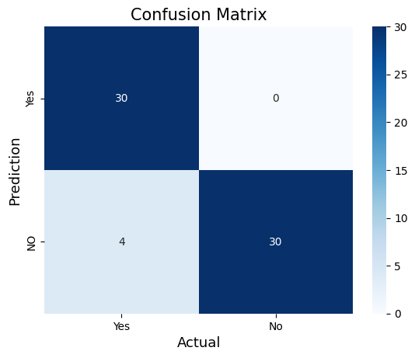

Fig. 5. Confusion matrix obtained for InceptionV3+VGG19 model

The ROC curves of the InceptionV3+VGG19 model is shown in Fig.6. This is a graphical representation of a binary classifier system's performance. It is calculated by comparing the true positive rate (TPR) to the false positive rate (FPR).

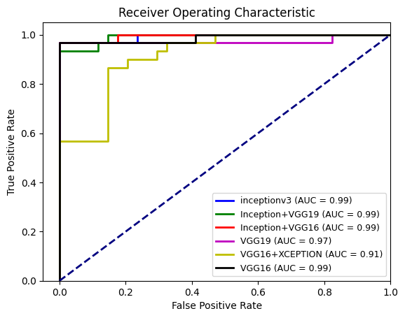

Fig. 6. ROC curve for All model.

## Results comparison with previously proposed models.

The outcomes obtained by combining the best CNN model with the recently proposed DL approaches for automated detection of brain tumors using the Brain MRI dataset are compared in Table.4. The proposed method performed better than the other existing systems, as can be seen. To verify the CNN models, the proposed paper took a sizable number of brain MRI samples into account. However, the dataset used in the proposed investigation shows an equal distribution of classes for cases of normal and brain tumour disease. Using the offline augmentation technique, the class imbalance issue was overcome.

**Table 4**

Previous papers on Brain tumor

Author (year) Method ACC

Mohammadi et al. [3] Custom Model 86.56%

Maheshwari et al. [4] ResNet50 95%

Charfi et al. [7] PCA 90%

Vani et al. [8] SVM 81.48%

Citak et al. [9] SVM, multi-layer perceptron 93%

and logistic regression

**Proposed Method InceptionV3 + VGG19 96%**

*Table 4*: Comparison with related studies on brain tumour

# Conclusion.

A concatenated CNN model based on transfer learning has been proposed in this paper for accurate classification of brain tumor from normal brains using MRI images. Eight pre-trained CNN models applying the method of TL were used and their outcomes across a collection of publicly accessible MRI samples were compared while taking into account several important parameters. According to the analysis, InceptionV3+VGG19 with Adam as an optimizer along with the learning rate (0.0001) with an accuracy of 96% that exceeded other existing networks and therefore, considered as a potential model for brain tumor detection. The experimental Results show that, compared to earlier proposed approaches, the neural network's proposed model offers promising results and performs exceptionally well in brain tumour detection. As a result, the proposed model might be utilized as a practical approach for doctors to provide appropriate treatments for the fast detection of brain tumor. Our future work is to expand by adding different optimization methods for the optimization of the parameters of the Adam optimizer.

##### References

1. Arokia Jesu Prabhu, L., and A. Jayachandran. "Mixture model segmentation system for parasagittal meningioma brain tumor classification based on hybrid feature vector." Journal of medical systems 42 (2018): 1-6.
2. Mohsen, Heba, et al. "Classification using deep learning neural networks for brain tumors." Future Computing and Informatics Journal 3.1 (2018): 68-71.
3. Afshar, P., Mohammadi, A., & Plataniotis, K. N. (2018, October). Brain tumor type classification via capsule networks. In 2018 25th IEEE International Conference on Image Processing (ICIP) (pp. 3129-3133). IEEE.
4. Saxena, P., Maheshwari, A., & Maheshwari, S. (2019). Predictive modeling of brain tumor: A Deep learning approach. arXiv preprint arXiv:1911.02265.
5. Shahzadi, I., Tang, T. B., Meriadeau, F., & Quyyum, A. (2018, December). CNNLSTM: Cascaded framework for brain Tumour classification. In 2018 IEEE-EMBS Conference on Biomedical Engineering and Sciences (IECBES) (pp. 633-637). IEEE.
6. Mohsen H, El-Dahshan ESA, El-Horbaty ESM, Salem ABM. Classification using deep learning neural networks for brain tumors. Future Comput Inf J 2018;3(1):68–71.
7. Charfi S, Lahmyed R, Rangarajan L. A novel approach for brain tumor detection using neural network. Int J Res Eng Technol 2014;2:93–104.
8. Vani, N., Sowmya, A., & Jayamma, N. (2017). Brain Tumor Classification using Support Vector Machine. International Research Journal of Engineering and Technology (IRJET)..
9. Citak-Er F, Firat Z, Kovanlikaya I, Ture U, Ozturk-Isik E. Machine-learning in grading of gliomas based on multi-parametric magnetic resonance imaging at 3T.Comput Biol Med 2018;99:154–60.
10. Q. V Le, “Building high-level features using large scale unsupervised learning,” in *2013 IEEE international conference on acoustics, speech and signal processing*, 2013, pp. 8595– 8598.
11. <https://www.kaggle.com/datasets/sartajbhuvaji/brain-tumor-classification-mri?resource=download>
12. Szegedy, Christian, et al. "Rethinking the inception architecture for computer vision." Proceedings of the IEEE conference on computer vision and pattern recognition. 2016.
13. Siddique, Md Abu Bakr, et al. "Deep convolutional neural networks model-based brain tumor detection in brain MRI images." 2020 FourthInternational Conference on I-SMAC (IoT in Social, Mobile, Analytics and Cloud)(I-SMAC). IEEE, 2020.
14. Lin, Chunmian, et al. "Transfer learning based traffic sign recognition using inception-v3 model." Periodica Polytechnica Transportation Engineering 47.3 (2019): 242-250.
15. A. Krizhevsky, I. Sutskever, G.E. Hinton, ImageNet classification with deep convolutional neural networks, in: Advances in Neural Information Processing Systems, 2012, pp. 1097–1105.
16. D.P. Kingma, J. Ba, Adam: A method for stochastic optimization, 2014, arXiv preprint arXiv:1412.6980.